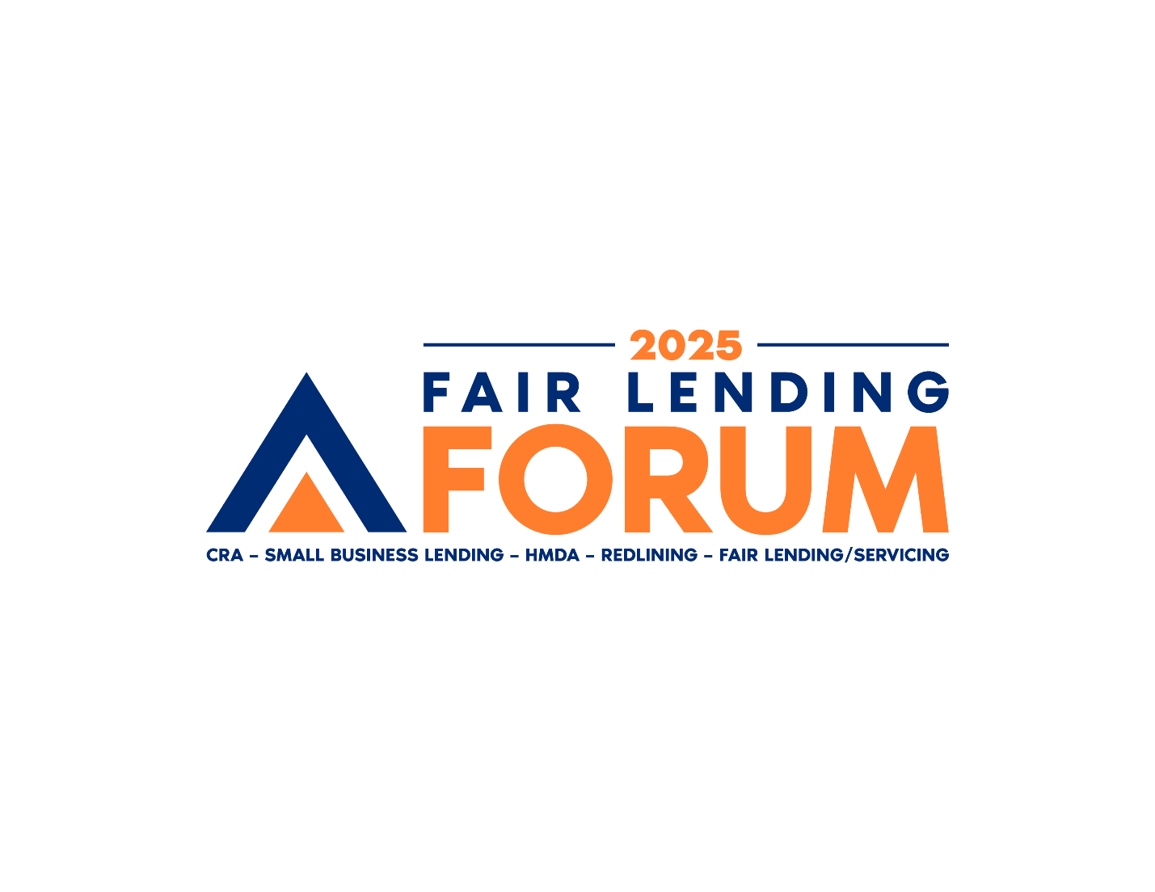

**MAKING YOUR CASE TO ATTEND**

Below is a sample letter to your boss that will explain why your attendance at the   
**2025 Fair Lending Forum** is a good investment.

Dear [Name],

I am writing to request your approval to attend the [**2025 Fair Lending Forum**](http://www.fairlendingforum.com), scheduled for Wednesday, May 7th – Friday, May 9th in Washington, DC at the Marriott Marquis Hotel. As our industry continues to evolve, staying ahead of regulatory changes, best practices, and innovative solutions within the industry is crucial for maintaining our competitive edge and ensuring compliance.

Here are several compelling reasons why my attendance would be a valuable investment for our organization:

* **Enhancing Compliance Knowledge**  
  The Fair Lending Forum will feature expert speakers from regulatory bodies and industry leaders to legal experts who will provide insights into the latest regulations and enforcement trends. By attending, I will gain a deeper understanding of compliance requirements, which will help us mitigate future risks and avoid potential penalties.
* **Learning Best Practices**  
  The event offers numerous sessions focused on the latest best practices. These sessions will cover topics around areas such as CRA, Small Business Lending/1071, HMDA, Redlining, Fair Lending, Fair Servicing and more. Bringing these best practices back to our organization will enhance our strategies and improve our overall operational efficiency.
* **Networking Opportunities**  
  Attending the Fair Lending Forum will provide invaluable networking opportunities with peers, industry experts, and potential partners. Building these connections can lead to collaborative opportunities, sharing of insights, and potential partnerships that could benefit our organization in the long run.
* **Staying Ahead of Industry Trends**  
  The forum will showcase cutting-edge technologies and innovative solutions that can help us stay ahead in the industry. Learning about these advancements will allow us to explore new tools and strategies to enhance our practices and maintain our position in the market.
* **Professional Development**  
  Attending this forum will contribute to my professional growth and development. The knowledge and skills I will gain from this experience will not only benefit me but also empower me to contribute more effectively to our team and the organization as a whole. And by attending, I will receive CEUs.

I am confident that the insights and connections gained from attending the 2025 Fair Lending Forum will provide a significant return on investment for our organization. The Fair Lending Forum is one of the most cost-effective informative events in the industry. That said, to minimize the impact on our budget, I will ensure that I take advantage of any early-bird discounts. Also, there are registration rate discounts offered if there are 5 or more attendees from our organization.

Thank you for considering my request. I am eager to discuss how attending the Fair Lending Forum can align with our organizational goals and contribute to our continued success.

Sincerely,

[Your Name]  
[Title]